Jeffrey Crist, Board Member • Dean Tamburri, Vice Chairman • Vincent Odock, Secretary • James Rinaldi, Board Member
Susan Walski, Board Member • Marc Greene, Board Member • Giovanni Palladino, Board Member • Linda Muller, Board Member
Bill Fioravanti, Chief Executive Officer • Susan R. Katzoff, General Counsel • Christopher C. Canada, Bond Counsel

Date: From: RE:
May 14, 2024
Jeffrey D. Crist
Next Meeting Date

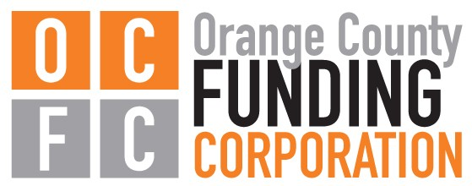
OCFC Governance Committee Meeting Notice

The next Governance Committee Meeting of the Orange County Funding Corporation is:

Monday, June 10, 2024
at 4:30pm

OC IDA Headquarters
4 Crotty Lane, Suite 100
New Windsor, NY 12553

To watch the livestream, please visit our website: www.ocnyida.com

Orange County Funding Corporation
4 Crotty Lane, Suite 100 • New Windsor, NY 12553
Phone: (845) 234-4192 • Fax: (845) 220-2228 • Email: business@ocnyida.com

